**LAB SHEET 6**

Designed using draw.io( <https://app.diagrams.net/> )

NADUNI KODIKARA

29861

FOC 23.1

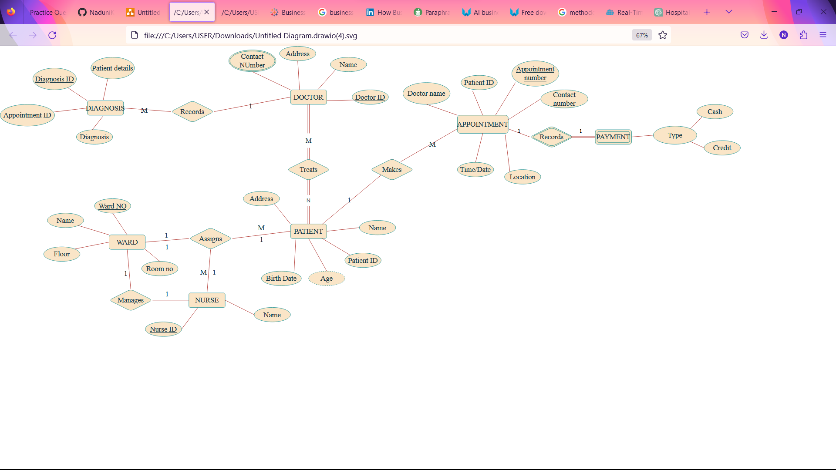ASSUMPTIONS

* Identified payment as a weak entity because payment exists if the appointment is completed.